# Stage 3 Report: A better Connect

# Socially Awkward Penguins

|  |  |  |
| --- | --- | --- |
|  |  |  |
| Evan Louie |  | Jeff Chan |
|  |  |  |
| Weifon Liu | Pen-GUI | Sandy Fang |

## Part A1: Low fidelity Prototype

Inheritance

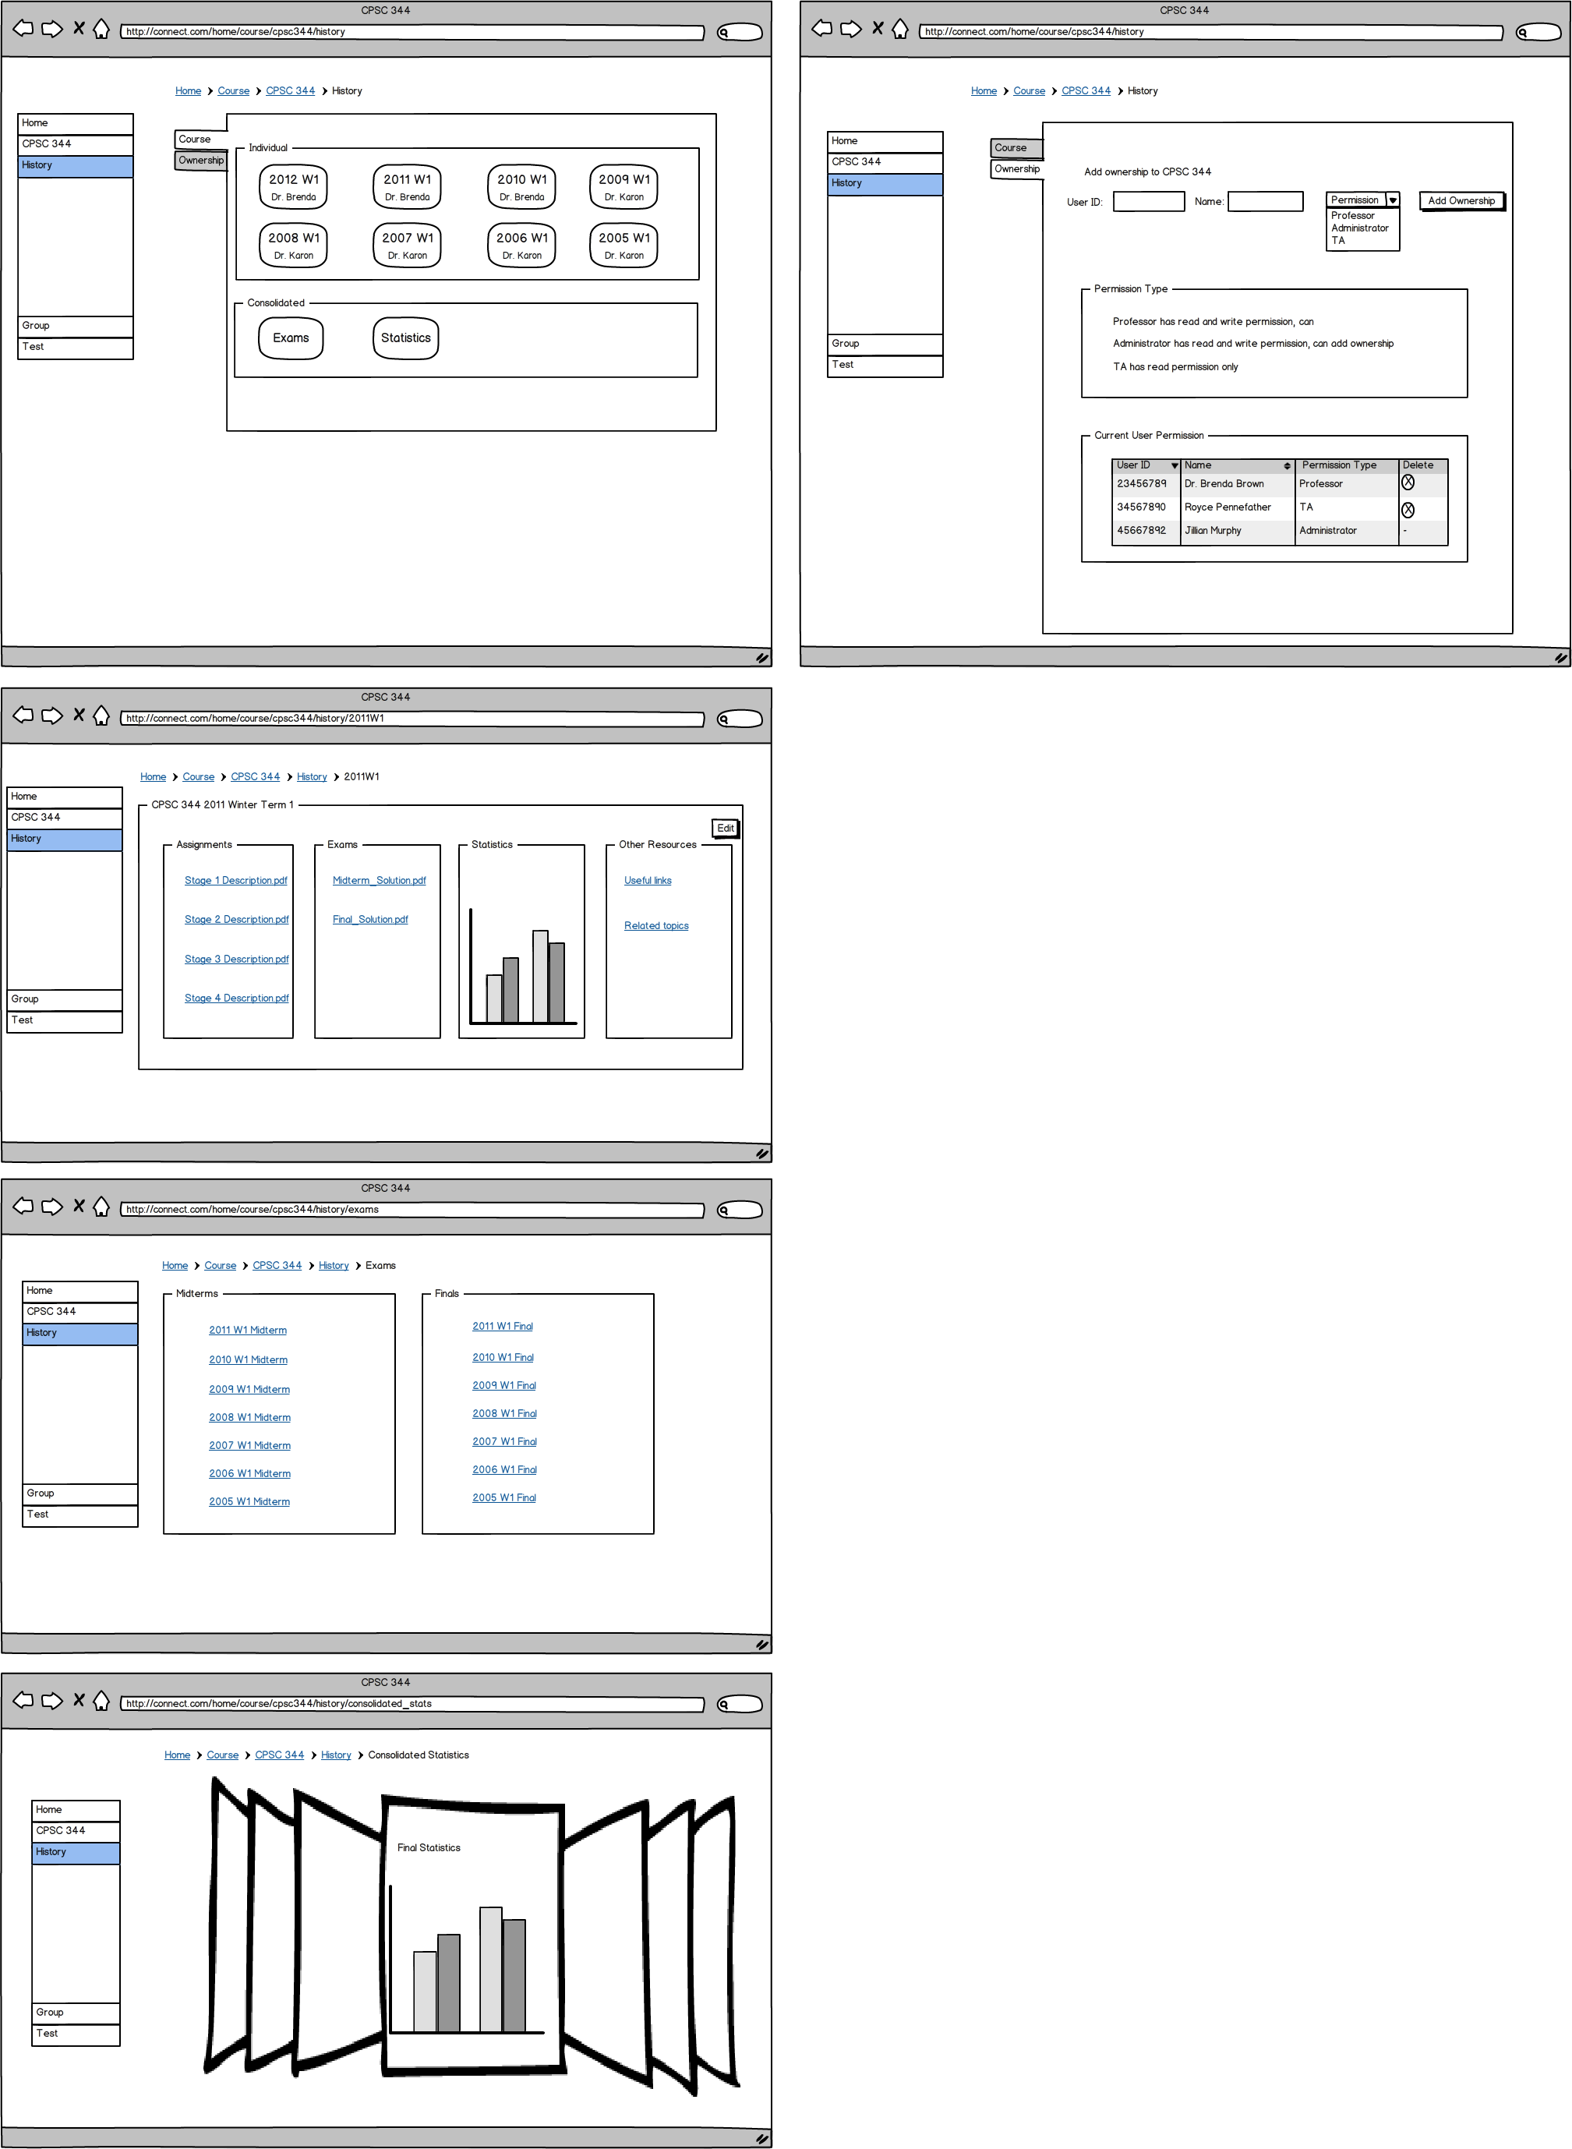

Quiz Creation

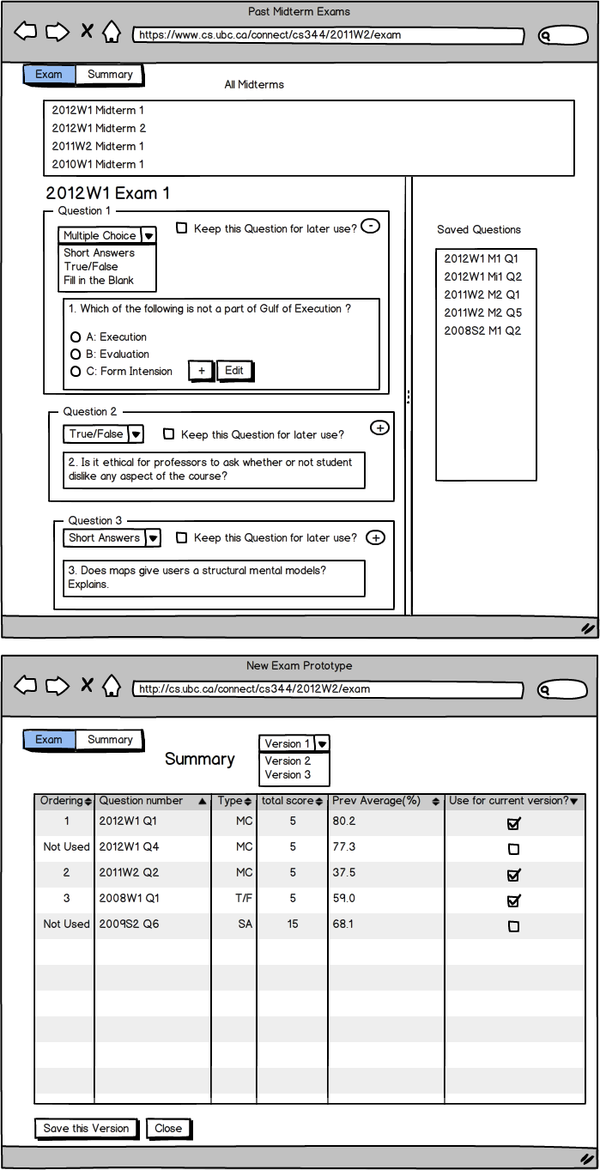

## Part A2 Description and Walkthrough

## Description

For our medium fidelity prototypes, we have actually made a different prototype for each task example (see appendix A.1 of this Stage for revised task examples). The inheritance and grouping prototypes were made in advanced HTML whereas the quiz creation prototype was made in Visual Basic. These technologies were chosen based on which methods would allow us to achieve our desired functionality most efficiently and which methods would produce our desired result most accurately.   
The main goal of our prototype for our inheritance task example is to implement the functionality and be able to walk through it. It was very important that we were able to get something that could be tested since this feature is rather unique and hard to visualize otherwise. The goal of our quiz creation and grouping prototypes is not only implementing the functionality, but also making the tool simpler and more user-friendly. This was a goal that was set after receiving feedback from Connect users in Stage 2 that the tools were difficult to use. Another thing we found out was that users had a hard time finding features within connect so we’ve added a side-bar which can be found across all our prototypes. Features like these make it easier for novice users, which is the demographic that we are most interested in since we believe that there are very few advanced users out there.

## Walkthrough Report

Inheritance:  
- the simplistic UI made finding previous course material was very easy  
- cover flow may be unnecessary.   
- adding ownership to courses was very straightforward since the parts of the ‘ownership’ tab is split out in a very organized way.  
  
Exam creation integrated with inheritance:  
- the prototype only has two pages and, without animation, user is more or less overwhelmed  
- Saving different version of the same exam can be a hard-to-get concept  
- It is not obvious how changing question type really works with a 2 page only prototype  
- Our cognitive walkthrough showed that users can do “selecting different exams, editing questions, saving questions, and customizing different final versions”

## Appendix A.1 Revised Task Examples

## Inheritance

Dr. Brenda Brown is a UBC computer science professor who is currently teaching CPSC 344, CPSC 410, CPSC 121, and CPSC 110.  She has been teaching CPSC 344 for the past 3 years and is about to teach a different computer science course.  Dr. Brad Williams (with user ID 43957247), who is about to take over CPSC 344 has asked her to share any useful materials with him.  Brenda, who has always been very careful to document, take notes on her course have gathered 3 years’ worth of knowledge and resources in the course and thanks to the previous CPSC 344 professors for sharing the course resources with her, she did not have to create all the materials from scratch.  Before she shares the course resources with Brad though, Brenda remembers that the "Related topics" link in 2011 Winter Term 1 is no longer relevant and wishes to delete them so Brad wouldn't be confused.  Also, Brenda's TA, Royce Pennefather (user ID 68371055) is hired by Google and will no longer help out with the course.  Brenda wants to update the current user permission of CPSC 344 to not include Royce before sharing the course with Brad.  At the same time, Brenda wishes to continue her ownership with CPSC 344 so she can still view, edit and upload any contents.

Summary of Revision:  
This task example is changed to provide more insight into what the user is trying to do and how course inheritance makes life easier for instructors, as well as be more design independent.

## Quiz Creation

Dave, a math professor of UBC, is currently teaching a math 210 course. This course has been around for many generations and Dave just got inherited the course materials, such as exams, practices, slides, and student performance data from the previous course. Before the midterm exam, Dave decide to mix and reuse the exam from previous two years. At first, he wants to see each exams, and, with the reference of difficulty rated by statistics of student grades on each question, he wants to choose some of the questions and add them to the attempt new exam. After adding questions, he wants to compare questions together and delete repetitive questions, so that he can, then, edit the remaining questions by changing some values around. Moreover, he also wants to change some questions from multiple choice to true and false, or the other way around with the reference of original exam answers and comments. Finally, he wants to save the template of these exams so that he can have multiple versions of the midterm.

Summary of Revision:  
This task example will be an integration of test creation and course material inheritance. It must involve viewing individual exam, saving questions to “exam prototype”, removing undesired questions from the prototype, editing questions, and populating different versions.

## Grouping

Jeff is a UBC Connect user and wishes to start a collaborative group within a CPSC344 class. Jeff goes to the CPSC344 group page and chooses to create a sub-group. He invites his project group from his lab section to join his group. His group receives an email notification and promptly accepts the invites. Upon acceptance, the users will join the group and be able to see whichever documents, announcements, wikis, etc... which are shared amongst the group. Before the day the assignment is due, all members log onto Connect to edit their assignment live. Once they’re done, they submit the assignment directly. Later on in the term, Jeff gets busy with other courses and is unable to manage the group himself, so he promotes another user to group owner and group management rights will be shared amongst them. Jeff posts regular updates as announcements on the groups page as well as start IRC style live chats with one another to collaborate on ideas.

Summary of Revision:  
Unchanged from Stage 2

## Part B Evaluation Plan

Goals of Evaluation:

1. Is the course inheritance feature an effective and easy to use way of inheriting content from previous years  
 2. Are the group management and quiz creation tools easier to use compared to the current Connect  
 3. Are the features easy for the user to find

Type of Evaluation:

For our Stage 4 evaluation, we will once again use semi-structured interviews to gather data from users. This method was extremely effective for us in Stage 2. Every user may have different opinions about what they thought were positive changes or negative changes, so interviews allow the participants to elaborate on these tangents. We want very specific details about what users think of our prototype and interviews provide a level of flexibility that no other method does.

Participant Pool:

The participants of the evaluation process will once again consist of both students and instructors who are novice Connect users. If possible, we would like to interview the same people as last time so we can get feedback on the improvements made after their last interview. Even if it were not possible, it is very important to have at least one instructor and one student go through the evaluation since instructors are the only ones who will use the quiz creation and inheritance features, whereas the group management features will primarily be used by students.

Evaluation protocol

Our evaluation will take place in an environment where it is just the interviewer and the interviewee, so that that it can be free from distractions. The data will be collected as qualitative data rather than quantitative since we have a small participant pool and we expect the interview data to be very detailed and personal. The interview for students will focus on the group management tool and the new sidebar. The instructors will also be asked about these features in addition to the quiz creation and inheritance tools. The student interview should take around 10-15 minutes, and the instructor interview will take 20-30 minutes.

## Part C Medium Fidelity Prototype

Prototype Rationale

Our prototypes are mostly vertical prototypes as they focus on the specific features that we implemented based off our task examples. We want our features to be usable. The one part of our prototype which is horizontal is a new home page which we have made in order to access our features.

The functionalities that our prototypes provide are: the ability to inherit course content from previous years, the ability to create a quiz and inherit questions from old quizzes, and the ability to create and manage a group.

We tried to make our prototypes look as appealing and realistic as possible, but it was not that important to us. The focus of the prototypes is the functionality and usability.

The tools we have used to create our prototype are Visual Basic for the quiz creation and Advanced HTML for inheritance and group management. These tools were picked based off the skills of each member and what could be used to create what we need most efficiently. Advanced HTML is ideal since our product is a webpage, but for quiz creation which is a complex feature, Visual basic was used since it was more efficient for our needs.

## Illustrations

|  |
| --- |
|  |
|  |
| Figure 1.1 Homepage. What you see when you first log in |
|  |
|  |
| Figure 1.2  Course Homepage. What you see after you’ve selected a course from the Homepage |
|  |
|  |
| Figure 2.1  Course inheritance main page |
|  |
|  |
| Figure 2.3  The view of course inheritance after you’ve selected a year to inherit from |
|  |
|  |
| Figure 3.1  Inheriting quiz questions from previous quizzes |
|  |
| Figure 3.2  Summary of a quiz composed of inherited questions |
|  |